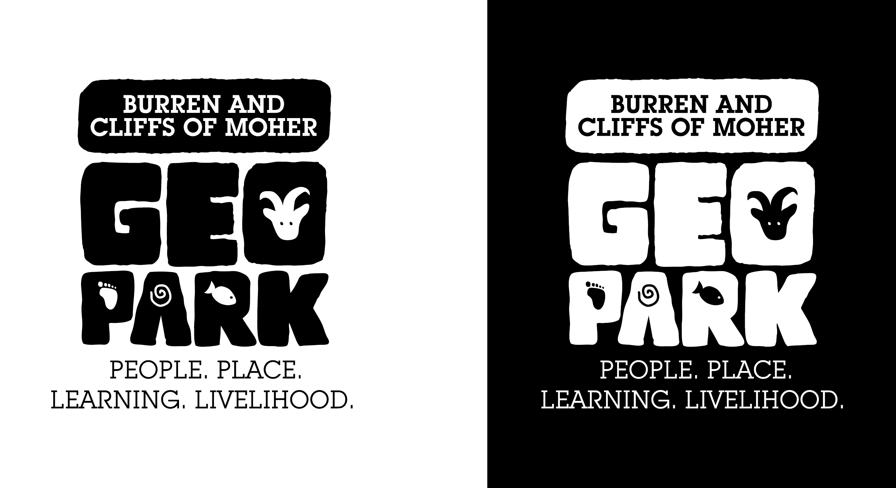LIFE11 ENV/IE/922
Minutes of Meeting

Project | Geopark LIFE Partners Meetings
Date | 22/10/2014
Location | Civic Room in Ennis Town Council. Buttermarket Building, Drumbiggle, Ennis.

Attendance |  | Person | Organisation |  | Abbr.
Apologies |  | Ger Dollard | Clare County Council |  | GD
Yes (Chair) |  | Monica Meehan | Clare County Council |  | MM
Yes |  | Helen Quinn | Clare County Council |  | HQ
Apologies |  | Risteard Ua Croinin | Clare County Council |  | RUC
Apologies |  | Congella McGuire | Clare County Council |  | CMcG
Yes |  | Tracey Duffy | Clare County Council |  | TD
Yes |  | Joan Tarmey | Clare County Council |  | JT
Yes |  | Sarah Gatley | Geological Survey of Ireland |  | SG
Yes |  | Pat O’Connor | Ex-Director Geological Survey of Ireland |  | POC
Yes |  | Michael Fitzsimons | Fáilte Ireland |  | MF
No |  | Carleton Jones | NUIG |  | CJ
Yes |  | Gabriel Cooney | UCD |  | GC
Apologies |  | Beatrice Kelly | Heritage Council |  | BK
Apologies |  | Margaret Keane | National Monuments Service |  | MK
Yes |  | Christine Grant | National Monuments Service |  | CHG
Yes |  | Hugh Carey | National Monuments Service |  | HC
Apologies |  | Ken Curley | Office of Public Works |  | KC
Yes |  | Enda Mooney | National Parks & Wildlife Service |  | EM
Yes |  | Emma Glanville | National Parks & Wildlife Service |  | EG
Apologies |  | Katherine Webster | Cliffs of Moher Visitor Experience |  | KW
Yes |  | Christy Sinclair | Burren Ecotourism Network |  | CS
Yes |  | Richard Morrison | Burrenbeo Trust |  | RM
No |  | Michael McGrath | Farmer Representative |  | MMcG
Yes |  | Eoin Hogan | RRO, Clare Local Development Company |  | EH
Yes |  | Chris Corlett | Cultural Tourism Officer, Dept. AHG |  | CC
Yes |  | Brian Callinan | Consultant |  | BC
Yes |  | Tina O’Dwyer | B1 Co-ordinator |  | TO’D
Yes |  | Siobain O’Brien | Admin/IT support |  | SOB
Yes |  | Eamon Doyle | Geopark Geologist |  | ED
Yes |  | Kelly Humphries | Communications Co-ordinator (maternity leave cover for Laura Cotter) |  | KH
Yes |  | Zena Hoctor | B2 Co-ordinator |  | ZH
Yes |  | Carol Gleeson | Manager |  | CG
1.0 | Welcome and Opening Introductions  - Apologies given for those absent.  - MM introduced CC from Dept. AHG  - CC spoke about his new role within the Dept and NMS and how the Service is developing its tourism brief in a more integrated inter departmental fashion, and in engaging more with communities  - Eoin Hogan, RRO with Clare Local Development Group was introduced and is representing CLDC and the Rural Recreation Scheme  - Zena Hoctor, B2 Co-ordinator and Kelly Humphries, Maternity Cover for Laura Cotter, were introduced.  - MM offered congratulations re recent awards for the Geopark (Responsible Travel & Tourism Awards and Geosites Top 100)
2.0 | Review of Minutes  Minutes of previous meeting accepted. Proposed by RM, seconded by PO’C
3.0 | Geopark Progress Report & Engagement by Stakeholders  - MM summarised the letter from EU Commission reporting on the outcome of the site visit by Dr. Lynne Barratt, the External Monitor in June– B1 is progressing very well. B2 & B3 needed improvement and suggested more participation from the partners. Action D (communications) and E (project management/admin) are progressing well also, however, the Commission expressed the need for baselines to be delivered by the end of summer under Action C.  - CG reiterated need for Time Sheets as this is how the commitment by partners is quantified by the Commission.  - MM again stressed the importance of the engagement of all partners in all aspects of the programme  - The Progress Report, circulated prior to the meeting, formed the basis of the ensuing discussions.
4.0 | Action B2 Habitats & Monuments  - ZH reported on B2. All of the demonstration sites have been assessed since the April meeting –the actual work programme and interventions will emerge out of these site assessments, and the condition reports to follow. The results of observation studies by Zena Hoctor, environmental monitoring by CAAS, and visitor surveys conducted by Millward Brown at each of the locations will also feed into demonstration site work programmes. Slieve Carron Nature Reserve is currently acting as a pilot for all partners to work collectively towards developing an integrated approach to visitor management. Counters installed at all demo sites will provide visitor numbers. Each demonstration site will address Universal Access issues where possible.  MM invited contributions from the partners engaging direction with B2 actions.  - CHG stressed the importance for improved communications and engagement between all partners and stakeholders that will ensure ongoing engagement beyond the life of GeoparkLIFE. CHG emphasised the potential benefits that can accrue from a level of partnership engagement at Dept. policy and at regional management levels  - CG reiterated that this level of partnership and engagement was one of the most important objectives of the programme.  - CHG noted that engagement with tourism businesses and conservation groups is vital for the success of the programme, this was supported by TOD, who suggested professionally facilitated dedicated meetings focusing on deeper integration between actions and stakeholder groups, as well as partners.  - POC suggested that the discussion begin with the chair of each sub-working group to encourage dialogue  - MM noted that membership of sub-groups is not set and crossover between groups should be possible and encouraged. Called for active involvement from all members across the board as project is now at a critical stage in its life span.  - Management team to investigate the potential for a facilitated meeting early next year. |  |  | ACTION
5.0 | Action B1 Tourism Enterprises  - TOD reported on progress in B1.  - 10 new businesses signed up to the Code of Practice, 47 businesses went through training last year  - BEN membership now stands at 47 Members, 15 Friends, 10 aspirant members  - New businesses include Aillwee Cave, Caherconnell Fort, Michael Cusack Centre, 2 Ferry Companies, 2 Hotel groups.  - suggested an awareness programme for those B&B/Guesthouse providers who are hesitant, to attract more accommodation providers to the Network.  - new this year is a  - Networking & Referrals programme,  - focused conservation events developed with appropriate agencies,  - Awards for achievements in the Code of Practice (Dec 4th). Issued invitation to steering committee to attend and to participate in judging the nominations for the various categories  - exercise needed to find a more realistic baseline of the number, profile and economic impact of tourism businesses in the Burren. The current baseline of 600 businesses is not truly reflective of the actual number that have an economic impact, and the current target of 100 businesses undertaking the Code may be too high.  - BC noted that the original target of 100 businesses impacted is achievable if we also measure the businesses attending the GeoparkLIFE awareness programmes and events, not just those engaging in the Code of Practice training.  MM invited contributions from the partners engaging directly with B1 (Failte Ireland (FI) and Environment section of Clare County Council (CCC)  MF - congratulations for Cliffs 1 Millionth visitor & Lonely Planet’s recent announcement of Ireland at #5 in Top 10 places to visit  - acknowledged great BEN showing at the German networking event in Galway  - a few new FI workshops coming up; Food Workshop on the WAW, Customer Care Workshop, Social Media Workshop, Customer Care Workshop  TOD noted how BEN members are very pleased with FI involvement and support  JT – CCC working to build baselines with data for a majority of businesses involved in the training  - training gives businesses an opportunity to engage directly with CCC and get feedback from businesses  TD- important that businesses see Clare County Council as not only a regulatory body but also as a support and source of information; Code provides the opportunity to build trust between CCC and businesses and awareness of CCC roles and functions |  |  | ACTION
6.0 | Geopark LIFE Action B3 Conservation Management  MM - working group has met numerous times since April and work programme and partner’s roles and functions have developed.  GC outlined the approach to addressing policy issues - there seems to be a barrier to some work on the ground in terms of policies, and there is a need to integrate sustainable tourism in both tourism and conservation policies at a higher level. The UCD aspect of the programme is to record and address the impacts of EU, National and Local policy on the project using the following approach:  - Phase 1 mapping of current policy; Phase 2 detailing policy issues as they arise during the work programmes, using the B2 demonstration sites and the B3 programme as case studies; Phase 3 Reconciling the policy issues sustainably at local level by improving communication and support networks; strengthening the interfaces between policies.  SG - GSI recognises that tourism is a key factor in protecting and maintaining the landscape and policy should reflect this.  BC – suggested that all phases of the policy research be completed within 12 months so the group would have 24 months to test the recommendations.  JT - Dept. of Environment policy would be key to this project.  MM invited other members of the working group to comment on progress.  RM – re: Monitoring and Burren Conservation Volunteers (BCV) involvement; volunteers cannot be organised yet until on-going monitoring programme is agreed.  - Meitheal will be organized for end of November to help rebuild walls on farmer’s land  - agreed the need for BCV to coordinate more with BEN members on their conservation efforts  CS - BEN very interested in the Meitheal idea and other BCV efforts as BEN member’s conservation work to date tends to not receive notice.  ED - new project in early Nov – tracing ground water to happen in the Burren in conjunction with Lisdoonvarna School, NUIG, CCC, & GSI  - schools will have a hands-on approach to the project  - GSI will be sending speakers to the school  - working with local communities; Lisdoonvarna Failte will make the info/outcomes available in an exhibition in the Spa Wells  - pleased to be listed in 100 Great Geosites in UK & Ireland, and also with 1 million visitors to the Cliffs; one of the few places on Earth where so many gather to look at rocks!  CG - stressed the importance of engaging stakeholders in the conservation projects, and continuing with the Leave No Trace Training for all BEN members  - Another aim of the B3 programme is to create skilled trainers from the pool of skilled people within the agencies and the Network  - Referencing the Monitoring Programme, an opportunity to engage with and utilise an EU FP7 Research Programm has emerged: Smart Open Data is a project which should provide a framework, using apps, to collect, collate, analyse and communicate the large body of data that will be accumulated during this project.  MM - appreciate the level of engagement since last meeting and the group is progressing well.
7.0 | Geopark LIFE Action D Communications  KH – numerous projects have progressed since last meeting, info points and signage are being re-branded, new products have been developed with BEN including Activity, Food, Walking. More will be developed with Accommodation and Visitor Centres. Website will be updated and re-organised to reflect the GeoparkLIFE programme more prominently.  The GeoparkLIFE Communications Strategy 2015 will target all project stakeholders, the media and sustainable tourism interest groups and will focus on the following:  - Geopark to position itself as an authority of sustainable tourism destination development with case studies from Code of Practice and results of surveys and research at Demonstration Sites.  - BEN to position itself as a network with expertise in implementing sustainable practices  - Strengthen the identity and definition of the Geopark with BEN members and their visitors  - Strengthen engagement in social media and all media fronts  - Apply for relevant awards  CG – other developments under Communications  - 7 GeoparkLIFE demonstration sites to have interpretative signage with LIFE branding,  - introducing 11 new geosites with new signage with LIFE branding  - Targeted materials for coach and taxi drivers, visitor centres and accommodation providers  - Utilising farm infrastructure at demonstration sites to act as interpretative/message mediums  - Cliffs of Moher is developing a new Geopark interpretation section  Coach Tourism Analysis  The economic and environmental impacts analysis results for the year Jan-Dec 2014from surveys at popular stopping points, with coach drivers, visitors and visitor centre managers will be available in early 2015.
8.0 | Administration  MM – Lynne Barett advised an advisory panel of non-agency people from the Burren communities should be created to liaise directly with working groups.  CG –recommended inviting the Advisory Committee to Burren Connect project to continue as panel members and invite new members as recommended by current Advisory Committee. This has the potential to include up to 20 people, so a panel structure would be the most efficient way to encourage direct communication with the project and engagement with the working programmes.  CG advised that NUIG is leaving the partnership as the original role is no longer applicable to the current project as it has developed. The funding allocated to NUIG can be redistributed.  MM – facilitators to be brought in to improve communication/work between all working groups in 2015  - All partners to submit time sheets asap.
9.0 | Next Steering Group Meetings  April 22nd, 2015  October 21st, 2015

