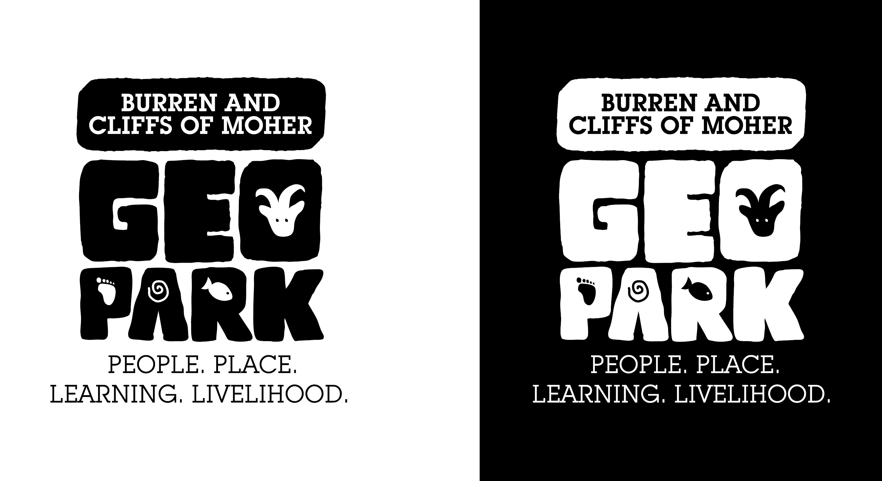
GeoparkLIFE11 ENV/IE/922
Meeting Agenda

Project |  | GeoparkLIFE Steering Group Meeting
Date |  | 02/04/14
Location |  | Burren College of Art, Newtown Castle, Ballyvaughan
10.00 | Minutes of last meeting
10.10 | Progress report on Geopark activities
10.30 | LIFE administrative matters; Time Sheets, administrative support and co-ordination roles
10.50 | Action B1 Tourism Enterprises work plan and progress report  Presentation on European Tourism Indicator System
11.40 | Action B2 Habitats and Monuments work plan
12.20 | Action B3 Conservation Management work plan
12.50 | Dates of next meeting  AOB
1.00 | Lunch
2.00 – 3.00 | Site Visit to An Rath (car pooling recommended)

